**Databases Laboratory Work Nr 2**

**Title “Database maintenance”**

**Prerequisites: SQL Manager 2017, Device with Internet Connection**

**Objectives: Learn to create management & maintenance plans, fileBLI size allocation. Defining logical and physical folders, scheduling,**

**Tasks:**

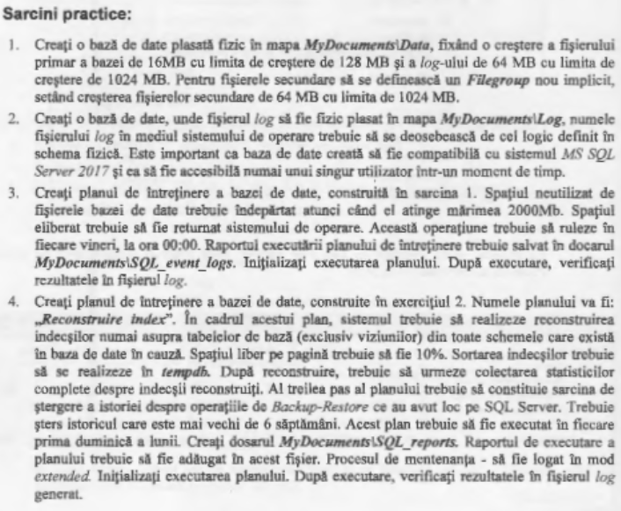

**Implementation**

Creating 3 files alongside with .log’s, setting their initial size and maximum growth size.

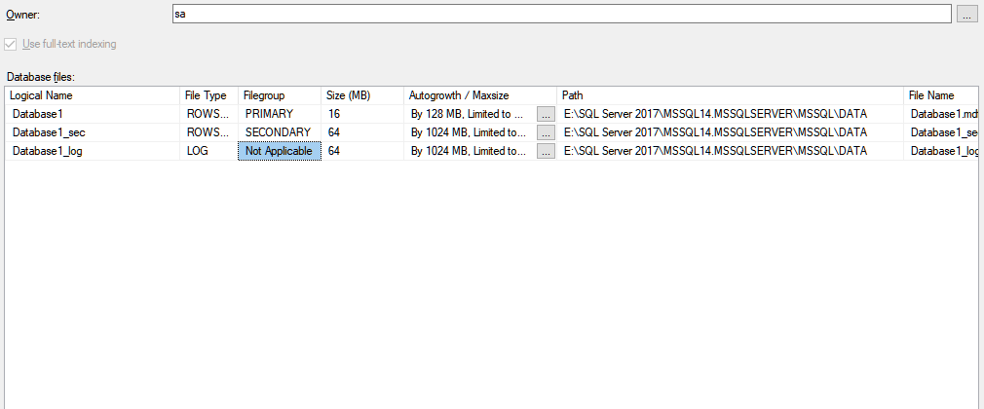

Setting the schedule for the maintenance plans.

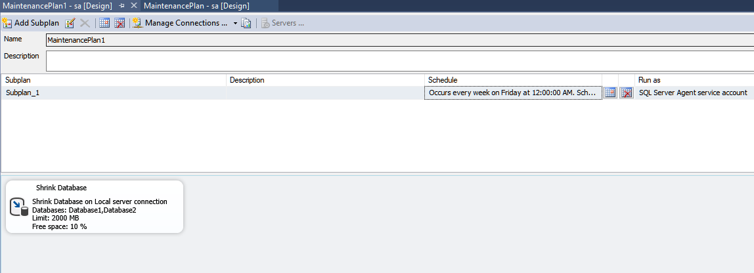

Memory and filegroup assignment for Task 2.

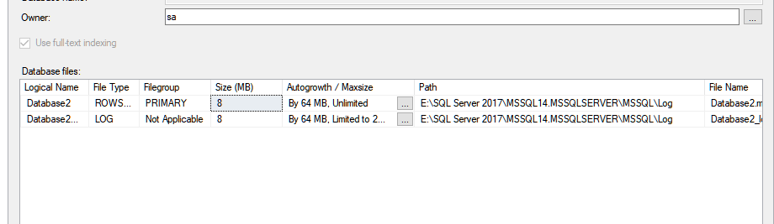

Setting up the maintenance tasks for Task 4.

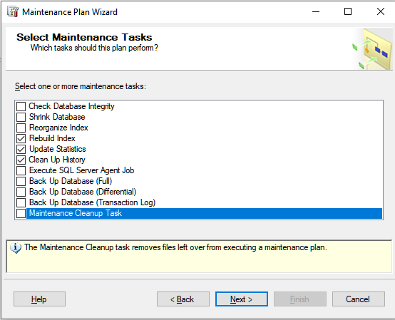

Proof of the 4th task accomplishment  
  
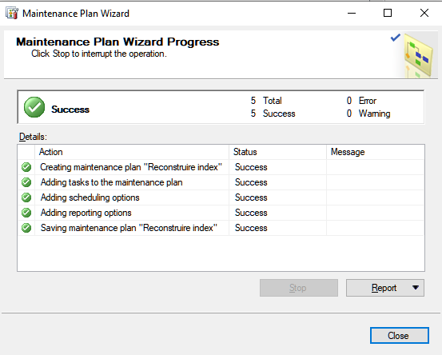

**Conclusion**

In this laboratory work, we’ve learned to set up a maintenance plan for our database, assign its tasks. Also task scheduling has been implemented in this work. We had to work with the maintenance wizard tool and assign such tasks as Index Rebuild and Database Shrinking.

Britchi Daniel